COST/BENEFIT

ANALYSIS

Fingerprint and Motor Vehicle Record Check Process Improvement

Arizona State University Human Resources – Recruitment and Selection

December 10th, 2015
Revision Sheet

Release No. | Date | Revision Description
Rev. 0 | 12/10/2015 | Completion of document and submission to ASU HR

1.0 GENERAL INFORMATION

GENERAL INFORMATION

1.1 Purpose

The Cost/Benefit Analysis provides adequate cost and benefit information for the impacts of improvement measures to further streamline and reduce inefficiencies in the fingerprint and motor vehicle check processes.

1.2 Scope

The scope of the project involves figuring out the effective measures for process improvement of the fingerprint and motor vehicle check processes. Starting off with understanding the processes and the experiences of the stakeholders involved. Then determining what are the issues or steps causing either redundancies or long completion times or errors. Understanding the root cause of the problems and then figuring out some possible objective solutions to overcome the issues. Eventually evaluating the possible options for improvements and measure out the cost-benefits of each improvement actions and understanding how it helps to give a better experience to all the stakeholders involved.

1.3 System Overview

The two processes involved in this process improvement project are part of a new hire or rehire or position change within the organization. The processes involved are the following:

- Fingerprint Background Check: The process wherein an individual's fingerprints are taken and crosschecked against a database of fingerprints is called a fingerprint background check. Background checks are a common step in the screening process of an individual not only in the United States, but throughout the world. The organization responsible for conducting the check is the Arizona State University Human Resource (ASU HR) department along with the collaboration of the Department of Public Safety (DPS) and Federal Bureau of Investigation (FBI).

The major application of the check is to understand the candidate’s history. The check will show up to 99 years of a person’s history. Usually a fingerprint check will give results regarding a person’s Employment and education history, driving record, criminal record, property ownership, workers' compensation records, bankruptcy history, and credit scores, and even more. This historical information is used to determine further a candidate’s capability and reliability in order to provide more safety to the organization and the stakeholders involved.

The operational flow of the process involves emailing and requesting a candidate to come in and do a fingerprint check after he has been offered a condition offer for a position that may deal with sensitive information, working with minors etc. from a department at ASU. The fingerprint is then documented and sent to DPS to retrieve results. After results arrive back from DPS the department is then informed. If there is a hit on the record, the issue is further evaluated with the candidate and the department to figure out the final result. The process is mentioned in further details in the process flow below:

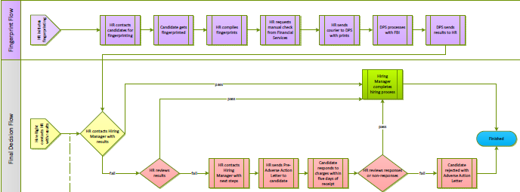

- Motor Vehicle Record Check: A Motor Vehicle Record (MVR) is a report of your driving history, as reported from your state Department of Motor Vehicles. Information on this report may include Driver’s License information, point history, violations, convictions, and license status on your driving record.

The major application of the check is to use it as a measure to determine whether the candidate has a good historical driving record in order to verify if the candidate will be trustworthy and be able to the tasks with reliability and responsibly.

The operational flow of the process starts with emailing the candidate and asking for his personal details including the driver’s license number. The information is then gathered to check in the state run system named ASEDRA. The results are then evaluated and informed to the hiring department. If the results are within ASU’s policy set limits then the hiring process moves forward. It further illustrated in details by the process flow below:

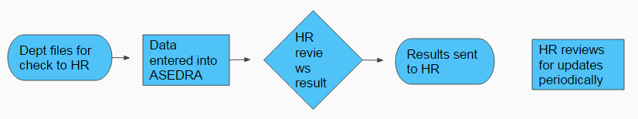

1.4 Acronyms and Abbreviations

- DPS: Department of Public Safety
- MVR: Motor Vehicle Record
- FP: Fingerprint
- ASU: Arizona State University
- HR: Human Resource
- FBI: Federal Bureau of Investigation
- POC: Points of Organizational Contact
- ASU Risk: ASU Risk Management

1.6 Points of Contact

1.6.1 Information

Provide a list of the points of organizational contact (POC) that may be needed by the document user for informational and troubleshooting purposes. Include type of contact, contact name, department, telephone number, and e-mail address (if applicable). Points of contact may include but are not limited to helpdesk POC, development/maintenance POC, and operations POC.

The different points of organizational contacts across different organizations include the following:

- Christina Scichilone (Coordinator - ASU HR): Christina.Haydu@asu.edu
- Daniel Klug (Director – ASU HR Selection and Recruitment): Daniel.Klug.1@asu.edu
- Christopher A Ramsey (Coordinator – DPS): CRamsey@azdps.gov

1.6.2 Coordination

List of organization that require coordination regarding the current process and the suggested process improvement include the following:

- ASU HR – Selection and Recruitment
- DPS
- Federal and State Government

2.0 MANAGEMENT SUMMARY

MANAGEMENT SUMMARY

2.1 Assumptions and Constraints

In order to move forward with the process improvement suggestions we had to take in to account some important assumptions and constraints and build hypothetical suggestions. This is due to the limitation of resources available and the involvement of various other organizations and stakeholders in which the ASU HR department may not have any control over. Due to this collaboration involvement requirement for any progress, we have made the assumption that all organizations involved in the process will be working together to come move forward with the process improvements. This including the involvement of the government, ASU HR, and ASU departments.

2.2 Methodology

Based on hypothetical solutions, there were three types of methodologies used to determine the improvement recommendations and consequently its cost and benefit analysis. The three types of methodologies used for both the FP check and MVR check is described by the table below:

 | Priority | Time | Cost | Benefit
Immediate | Low | Within 1 day to 1 month | Low. Easily Implementable | Slightly improve experience
Short Run | High/  Medium | Within 1 year | Medium. Requires involvement from stakeholders | Implement preventive measures
Long Run | High | Over 1 year to 5 years | High. Requires integrating organizations involved | Complete integration and automation  Reduce running cost and improve satisfaction of employees

2.3 Evaluation Criteria

The evaluation criteria is mostly based on cost and improvement completion time. Basing off of these two important factors, the three types of classification for improvements are made. Considering that the process improvement project is practically hypothetical, the best approach was to provide different options for improvement. Having different options will allow ASU HR to evaluate the ideas based on their budget, project completion time deadline, and the importance of a specific issue rectification and move forward with the suggested idea that matches accordingly. In this way ASU HR will be able to operate under their budget, evaluate alternatives, operate under the organizational objectives, match or exceed the operational efficiency requirement, and reduce operating costs.

2.4 Recommendations

The summary of recommendation for the FP check process are as follows:

- Immediate
  - Email department about updates
  - Inform candidate about timeline, parking, and policy
  - Extend walk-in times
  - Encourage fingerprint card
  - Data backup

- Short run
  - Barcode Tracker: Will be able to track and log each step of a candidate’s FP check and billing documentation and reduce manual data entry
  - Kenaxa Warning: Will warn the department hiring manager to ensure correct account number is entered and account has enough balance before submission for FP
  - Request for expedited service during peak season or more often

- Long run
  - LiveScan implementation and integration of systems

The summary of recommendation for the MVR check process are as follows:

- Immediate
  - Employment Status Verification: To divide the database into active and inactive employees
    - Use a new worker to evaluate the database
    - Use IT teams of ASU and ASEDRA to divide - more efficient
  - Clarify Driving Requirements: Evaluate if employees are driving or not and whether it is part of the job
- Evaluate from departments the employees who are driving or not
- Making it mandatory to include driving requirement field when posting a job
  - Increase ASEDRA Functionality: Make it more user friendly
- Create Excel reports to help crosscheck records and for data backup

- Short run
  - Adjust Risk Measurement Index: Including the adjusted weight on the faults and also including points accumulated
    - Will help identify which faults are more dangerous and provide classification
  - Link ASEDRA and Peoplesoft: Creating an automatic daily adjustment of active and inactive employees in both the systems

- Long run
  - Integration of Systems: Complete integration of database and operational activities between Peoplesolt and ASEDRA
    - ASEDRA will have a sub account for ASU for more convenience
    - Automatic daily adjustments of updates, and active/inactive employees
    - Automatic internal and external database update
    - Option to export excel reports

3.0 COST/BENEFIT SUMMARY AND IMPLEMENTATION DESCRIPTION OF FP CHECK

COST/BENEFIT SUMMARY AND DESCRIPTION OF IMPLEMENTATION of FP CHECK

In order to further elaborate and describe the improvement implementations and their cost and benefits applicable to ASU HR, a compiled representation is presented in the document to make it more convenient for readers. To make it further representative, description regarding the current process is also mentioned so that the changes can be evaluated in a more informed manner.

3.1 Immediate Improvements

The immediate improvements for the FP check process includes:

- Email department about every updates regarding the FP check a candidate
- Inform candidate about timeline, parking, and policy of FP
- Extend walk-in times to allow convenience for very busy candidates
- Encourage fingerprint card which can help further modernize the FP check in the future
- Data backup to ensure all data is archived and well

The recommended immediate improvements involve implementations that look to further enhance the experience of a candidate when doing a FP check. The improvements themselves are of low priority and low importance as it does not have strong implications to the current system. They will slightly improve the candidate’s experience while doing the FP check without adhering any extra cost. Overall the benefit may include a good word of mouth from the candidate to his network or other potential candidates for ASU.

3.2 Short Run Improvements

Barcode Tracker: Will be able to track and log each step of a candidate’s FP check and billing documentation and reduce manual data entry

Among all the recommendations, this option seems to be the most effective one. Throughout the FP check process we notice there is a lot of redundant data entry work. Such redundancy can be very boring for employees and make them feel that the tasks are less worthy. No matter what it is always crucial keep the employees motivated throughout their working time. In order to achieve automation of the data entry can overcome this issue.

Each FP check will be labeled with a unique id number which can be read by the barcode tracker thus giving a unique identification each candidate even with the same name and birth date. Then the barcode tracker can used to track all the logs of a particular and include it in its database. The software of the tracker will allow to get an exel format spreadsheet out of the database for unique id and their log times.

The snapshot below shows the various different data entry needed by each FP check in the current database:

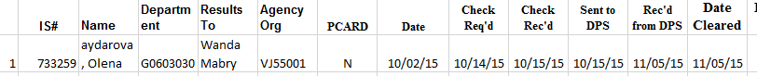

This can be easily implemented even with only a minimal one time cost of $900 and the potential intangible benefit retrieved from it can result in increased employee satisfaction. By considering only a minimal increase in satisfaction for a worker with salary with $50,000 can result in $5,000 of recurring benefit each year.

The link for information regarding the purchase of barcode tracker:
https://www.waspbarcode.com/barcode-system-starter-kits/waspnest-wcs3900-ccd-barcode-scanner

The following table shows the different implication and the summarized cost and benefit of implementing the barcode tracker.

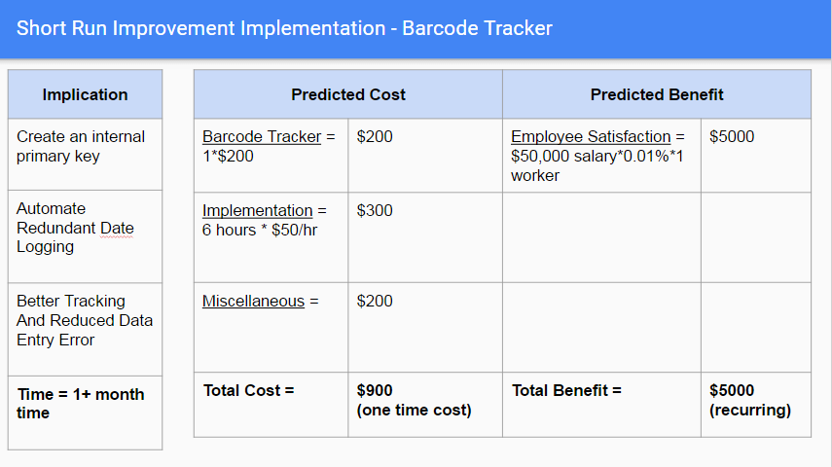

Kenaxa Warning: Will warn the department hiring manager to ensure correct account number is entered and account has enough balance before submission for FP

One crucial issue discovered in the FP check process was that before a package is sent to DPS, the information for all the candidates and the payment to DPS and the billing and payment between ASU HR and departments need to be perfect. Thus there was no room for data entry error. However, it was evident departments may sometime include wrong agency/account number for the billing of their candidate. Thus this creates a bottleneck in the whole process by not being able to process the rest of the candidates in the same package, as a package sent must contain correct in order for any of the candidates to be processed.

By creating the Kenaxa warning notification it can be ensured that the hiring manager of the department has entered the correct information so that the potential bottleneck can be avoided. This warning will pop before the submission of a FP check request saying “Are you sure the correct agency number has been entered?” There has already been a situation where a packet was with withheld for about three months and this will help avoid such issues. Avoiding such bottleneck in the hiring process will also allow to reduce the number of job offer denials expected by ASU.

Following is a screenshot of the agency number data entry in the Kenaxa form:


Following is the summary of implications and the cost/benefit for the Kenaxa warning implementation

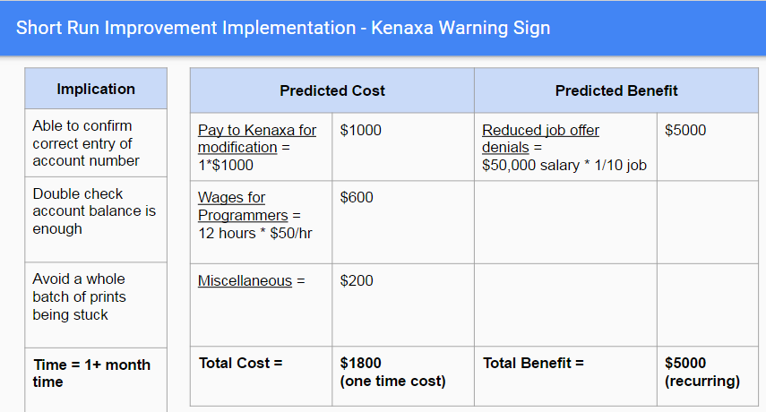

Expedited DPS Service: Hiring at ASU experiences seasonality every year thus the change in the number of FP checks needed can be predicted reasonably. In in order to accommodate that and provide a better experience to candidates looking to be hired, increased expedited service can be used by ASU HR in order to get results quicker and be able to keep up with the load. The increased cost can easily outweigh the benefit of ASU facing fewer job offer denials. The cost and benefit can be approximately estimated from the table in the last point.

3.3 Long Run Improvements

- LiveScan implementation and integration of systems

The government is currently using LiveScan only in police stations and at immigration border ports. LiveScan is a device where a person can just put their fingers on a machine and it will automatically scan the fingerprint. By assuming that in the future government allows LiveScan to be used throughout in public we can use them as our improvement implementation.

ASU HR will be able to use it exactly like how the government is using at this point. It will allow ASU to even get the results right away in seconds. This can be done even when the candidate is just coming in for an interview. The system can be integrated to ASU’s database as well thus completely forgoing the need of data entry labor. This will automatically update the records and help keep track. Overall employee and candidate satisfaction will increase and potentially a position may not be even need due to the automation thus saving costs.

Below is the table of the cost-benefit for the LiveScan implementation:

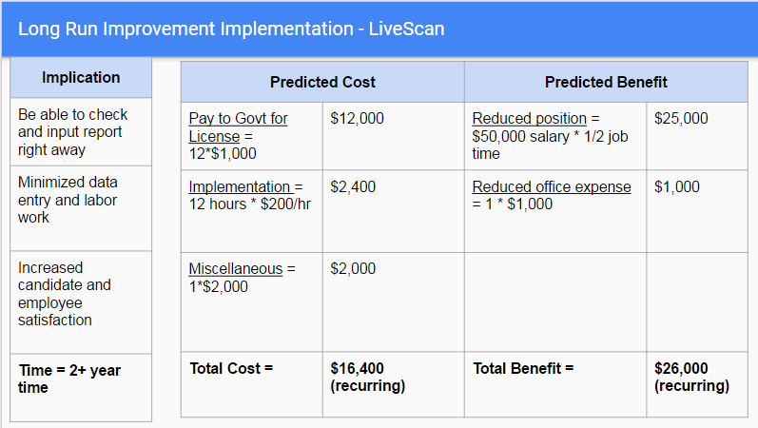

4.0 COST/BENEFIT SUMMARY AND IMPLEMENTATION DESCRIPTION OF MVR CHECK

COST/BENEFIT SUMMARY AND DESCRIPTION OF IMPLEMENTATION of MVR CHECK

In order to further elaborate and describe the improvement implementations and their cost and benefits applicable to ASU HR, a compiled representation is presented in the document to make it more convenient for readers. To make it further representative, description regarding the current process is also mentioned so that the changes can be evaluated in a more informed manner.

4.1 Immediate Improvements

Employment Status Verification: One of the most important issue regarding the MVR check process is that the database is never getting updated. Once a candidate’s information is entered it stays in the database overtime and there is no verification method in place to understand if that person is an active employee or not. In order to update the database with current active employees only, a manual verification of the database is needed. This can be a time consuming process but this task will be of high priority.

In order to come resolve this issue, two approaches may be used. One approach will include hiring a new part-time worker who is experience and can be efficient in going through documents or the ASU database manually. Another option will be to hire IT workers to work both on ASU and ASEDRA databases. ASU IT workers can be hired to do the complete job also. At first they can get a total list of the current active employees at ASU and then work with the organization involved with ASEDRA and retrieve the total ASU database from there. After retrieving both the databases, we can crosscheck each other sort out the current active employees matching in both the databases. After that, we can upload the active employee database back into ASEDRA and leave out the inactive.

The following table shows the implications and the cost-benefit involved with this implementation:

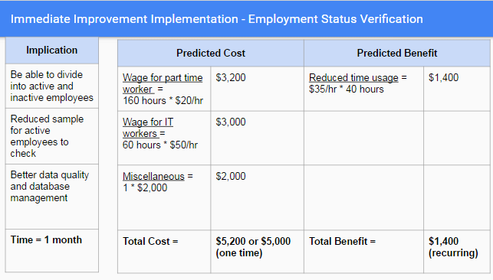

Clarifying Driving Requirements: Another important issue within the process is that we do not have an exact way to know if driving is actually within the requirements for the person working in a position. Thus in order to get a correct data, we will need ask have every department reach out to all their employees and by email and gather if driving ids required for their work or not from the employees. To avoid this issue coming up in the future, we will make it mandatory to include a “Driving Requirement” field mandatory when posting a job by a hiring manager.

The implications and cost-benefit involved with this implementation are as follows:

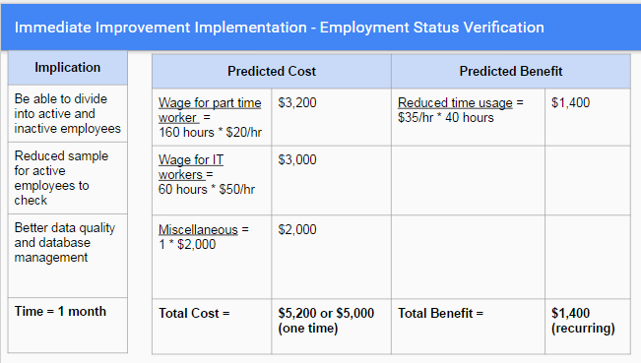

Increase ASEDRA Functionality: This can be an added implementation to the first one already mentioned above. Increasing the functionality of ASEDRA and making it user friendly can definitely make things much easier. For example if it is able to create excel reports, it will be much easier to work with the database from the different systems and maintain data integration.

The following table includes the details about the implications and the cost-benefit related to it:
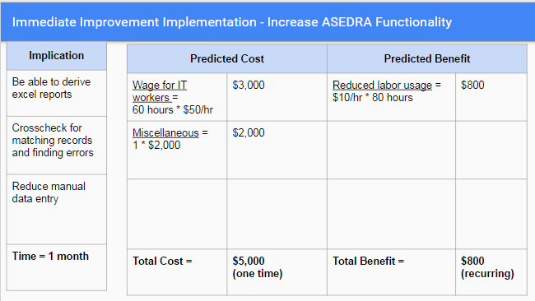

4.2 Short Run Improvements

Adjust Measurement Risk: Currently the measurement of whether a driver is of risk or not is based on if he collects points of 6 or more. However, this may not be the most appropriate approach as some faults may be more offensive to ASU’s policies and environment compared to others. Thus readjusting the measuring index can help verify better who may be a risk or not. If needed we can even create a probation range which may help drivers become more careful, thus applying preventive measures.

The following table shows the different implication and the summarized cost and benefit of implementing the adjustment of the measurement index:

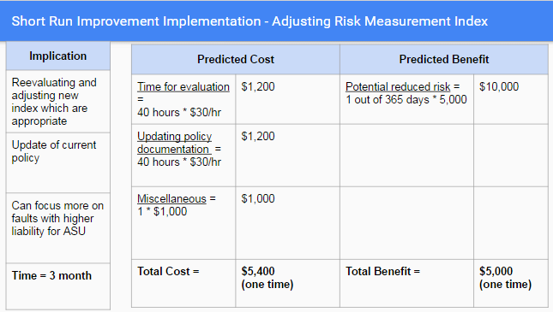

Link ASEDRA and Peoplesoft: Even though the first implementation mentioned above for the MVR including distinguishing the current and active employees from the databases and updating them, it will still keep the issue of continuously monitoring of the day to day update of active and inactive employees. Thus in order to tackle that an automated updating system needs to be implemented as checking the database manually every day is not the most efficient approach. With this implementation we will have ASEDRA and Peoplesoft completely integrated with each other and do an automated daily update of active and inactive employees. This will also allow to give a notification when a driver measures on the risk limit as it will run the database every day.

The implementation and the cost-benefit are:

